WAD Ruby + TDD Assessment 2

Name: Stefan Rudvin

Student id: 51549217

Stefan_Rudvin_51549217_report.pdf

# **Features**

1. **Introductory welcome message**

The game shows a welcome message when started.

1. **Start Message**
2. **Creator of Game**

The code shows the name of the creator

1. **Number of turns**

Number of turns through the turn variable that is incremented each time the user fails to guess a word correctly.

1. **Menu**

Menu with four options

1. **New game**

Option where user can reset settings and begin a new game.

1. **Analysis**

Option that shows previous guesses.

1. **Exit game**

Option that reset data and quits the game.

1. **Appropriate messages**

Game shows messages when input is not valid. Also tells the player when they lose or win the game.

To run this application, extract the .zip file and copy the ‘wof’ folder into your preferred ruby on rails IDE which supports Sinatra (Cloud9 IDE and Chrome browser are recommended).

Navigate to the ‘/wof’ folder and start the application with the command:

ruby wad_wof_run_01.rb

Design Flow Chart

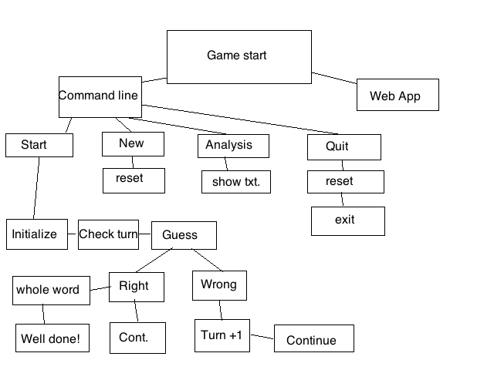

Appendices

1. **Introductory welcome message**
2. **Start Message**
3. **Creator of Game**

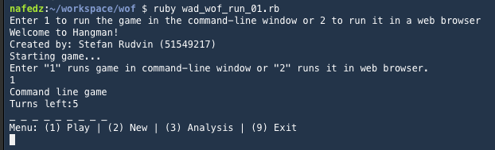

1. **Number of turns**

../../../Desktop/Screen%20Shot%202015-11-27%20at%2005.14.27.png

1. **Menu**
2. **New game**

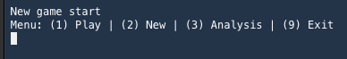

1. **Analysis**

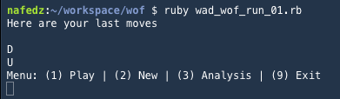

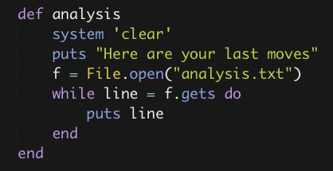

1. **Exit game**

**../../../Desktop/Screen%20Shot%202015-11-27%20at%2005.19.22.png**

1. **Appropriate messages**

Game shows messages when input is not valid. Also tells the player when they lose or win the game.

../../../Desktop/Screen%20Shot%202015-11-27%20at%2005.26.50.png

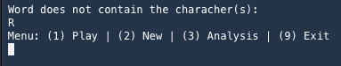

**Code**

**Main game**

